Subject: 70% OFF ONLY ON THIS BLACK FRIDAY. DON’T MISS THE CHANCE!

Dear Customer,

We are thrilled to announce that we IQCovers have opened the door for our valuable customers. In This BLACK FRIDAY we are offering the flash sale on our maximum products only for you.

WHAT WE ARE OFFERING ON THIS BLACK FRIDAY:
- We are offering up to 70% less in our products.
- No Shipping Cost will be added in this BLACK FRIDAY flash sell.
- We will provide a promo code if you buy products on this BLACK FRIDAY, by using this promo code you will get 50%-80% less on next purchase.

Here are the samples of our top rated products. Buy those products on https://www.ebay.co.uk/str/IQCovers?_trksid=p2047675.l2563

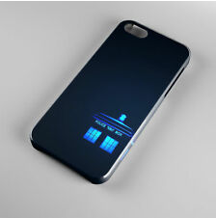 | 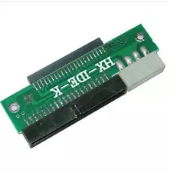 | – | 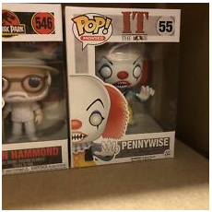
Tardis Phone Booth Dr Doctor Who Phone Case Cover | LAPTOP HARD DRIVE TO BIG IDE CONVERTER READER FOR PC | 15CM Amazon Fire Stick TV HDMI Male to Female Extender Extension Wire Cable/Lead | It Pennywise 2018 Number 55 Pop! Pop Funko Toy Collectible Rare
Original Price- £6.92  ON FLASH SALE - £2. 99 | Original Price - £12.49  ON FLASH SALE - £3.75 | Original Price- £3.40  ON FLASH SALE - £2. 50 | Original Price - £28.34  ON FLASH SALE - £8.50

So, don’t miss this chance, pick your products now on - https://www.ebay.co.uk/str/IQCovers?_trksid=p2047675.l2563 and make your BLACK FRIDAY more memorable with IQCovers.

We wish you have an amazing BLACK FRIDAY.
Cheers!

Kind Regards
Team IQCovers.

