Curriculum Vitae
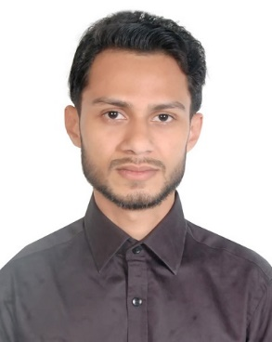
Arka Ghose

Present Address | : House No. 73, Madani Bag, Tilagor,  Sylhet Sadar-3100, Bangladesh
Mobile No. | : 01723 810003
Email | : arko.21stcentury@gmail.com

Career Objectives:

To pursue a challenging career and be a part of a progressive organization that gives a scope to enhance my knowledge and utilize my skills towards the growth of the organization.

Academic Qualification:

Degree | Course | Institute | Result | Duration | Passing Year
Bachelor of Engineering | Mechanical Engineering | Gujarat Technological University, Ahmedabad, India | CGPA: 6.02  out of 10 | 4 Years | 2018
H.S.C. | Science | Sylhet M.C. College, Sylhet | GPA: 4.60  out of 5 | 2 Years | 2012
S.S.C. | Science | Sylhet Govt. Pilot High School, Sylhet | GPA: 5.00  out of 5 | 2 Years | 2010

Areas of Interest:

- Industrial Engineering
- Production Technology
- Manufacturing Process
- Power Plant Engineering
- Internal Combustion Engines
- Automobile Engineering
- Oil Hydraulics & Pneumatics
- Renewable Energy Engineering
- HVAC
Summary of Abilities:

- Ability to work under pressure.
- Effective technical skills.
- Problem-solving skills.
- Interpersonal and teamworking skills.
- Verbal and written communication skills.

Personal Details:

Father’s Name | : Ranajit Prasad Ghose Profession : Govt. Employee
Mother’s Name | : Shukla Rani Ghose Profession : Govt. Employee
Date of Birth | : 20th February, 1994
Age | : 25 years
Gender | : Male
Marital Status | : Unmarried
Nationality | : Bangladeshi
Religion | : Hindu
Languages Known | : Bengali, English, Hindi, Gujarati
Present Address | : House No. 73, Madani Bag, Tilagor, Sylhet Sadar-3100, Bangladesh
Permanent Address | : Amo Pulpar, Chandpur Bagan-3321, Chunarughat, Habiganj,Bangladesh

References:

Professor Srinibash Dey  Retired Principal  M.C. College, Sylhet  Mobile: 01716 152247 |  | NiharKanti Roy  Accounts Officer  Intermediate and Secondary Education Board, Sylhet  Mobile: 01720 562996

Notes :
From Tilagor

He got 100% scholarship from Indian Government and Did Graduation from Gujarat Technological University in Mechanical Engineering

Confident English speaker and could explain himself well
Seems like a quick learner and energetic.

Shift - EST, BDT

Sherman is friend

Rob Comments: Arka This guy has potential to become a good VA – give him VA workshop
Workshop :
Workshop Score: 17
Online Test Score: 80%
Typing Speed : Average
Rob Comments: Arka – workshop is ok but not too good. Interview with me.

Krish: We can think over him for any English Speaker/Semi-Tech VA position.

