How to build employee loyalty?

The success of any business company is straight affected by the performance of the employees within the organization. So, it is really important for a company to build employees loyalty.

But how a business company do that? It’s a big question. Let's discuss this.

1.What is ‘employee loyalty’ means:

In simply employee loyalty is a term for a set of feelings that make employees feel involved in their present company and less likely to see a better opportunity elsewhere.
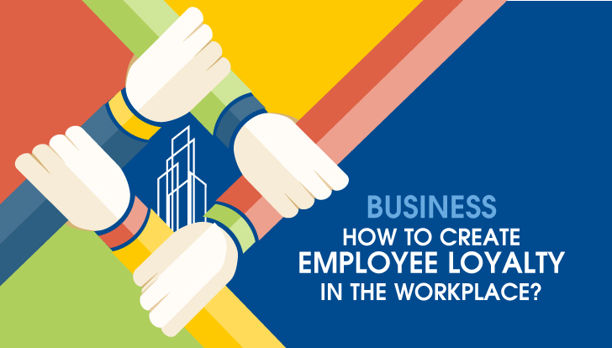
If you want to increase employee loyalty, you must have to increase the positive feelings and decrease the negative sentiments that your employees can feel as they have to be as much as loyal to the company.

2. Fair Salary:
If you are the owner of a company, you have to know what is the fair enough salary for an employee. If they think you are paying them less, then they will be demotivated to do well for your company.

Another thing every management team of a business company has to consider is paying the same salary among peers who are doing the same work,

3. Give employees more flexibility:

If you want to improve employee loyalty, then you have to give them more flexibility. Give value their decisions, feel them they are not just following the orders, they are making decisions.

The easiest way to increase employee loyalty is to have them established their work hours and decide whether and when to work remotely.

4. Ask for Feedback

Feedbacks from your employees is vital to make a better working environment. When the company owners ask for feedbacks from employees, they feel that they are equally as valuable as the management team.

5. Ask Questions.

Always communicate with your clients. Ask them random questions regularly. Questions can be related to personal or official.
For example, you can ask them. . .
~ “What are the thoughts of clients or customers about our business?”
~ “What do you enjoy most about your job?”
~” What is your vision for the future”?
You also can ask them some funny or non-official questions.
For example,

~” What is your favorite holiday destination?”
~” What is your favorite tv series or favorite musical band or favorite sports team?”
These sorts of questions will make employees more comfortable with you. They will be enough confident to discuss any topic regarding office with you. Day by day it will improve employee’s loyalty.

6. Celebrate Employees Achievement:

Always try to celebrate employee’s achievement. Celebrating work anniversaries displays that your company values long-term employees. It will make them loyal to the company, and they will hardly think about the job switch.

7.Improve the work environment:

Improve work environment is truly a mixture of the individual interaction between management and employees and individual interaction between employees. There is a certain quantity of job ability that comes into play but generally, it’s more about arrogances, personalities, and how well we all get along.

As a company owner, it’s your responsibility to keep your digit on the throb of the company’s culture and address any interpersonal problems that arise or not. If any problem arises then try to fix it smartly.

Above all, if you want your employees to become loyal to your company then you must have to be an example to them.

