WHITEBOARD ANIMATION:
Whiteboard animation is an easy illustration, which is drawn on a white background by the designer. It is often used to communicate complex ideas quickly and effectively, as it enables to communicate your message in an uncluttered way. Today, whiteboard animation is gaining popularity and companies across the globe are increasingly using it to promote, persuade, and educate the consumers.
The best technique to obtain quality animations without any hassle is to outsource the task to a reliable service provider like us. The superiority of whiteboard animation services to global clients. High-quality services will help you to precisely put across your message to your target audience in the most effective way.
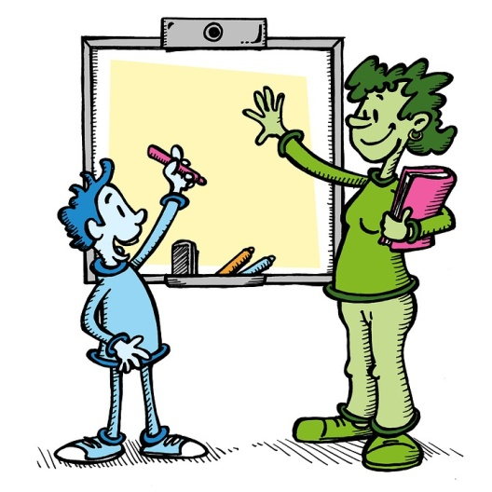
Fig: Whiteboard animation [This Picture is edited & it’s downloaded from Google free for use; even commercially]

WHITEBOARD ANIMATION SERVICES:
Also known as scribe and doodle animation, whiteboard animation is ideal for numerous purposes, including training and development, advertising, social media promotions, etc. The professionals will understand client needs and provide you with the best possible animation services.
Following are some of the major types of doodle animation services we offer –

Animations for Training Programs:
A company expands and gets new resources onboard, it is necessary to impart the new employees about the organizational goals and values. Provide top-quality custom whiteboard animation that enables businesses to impressively here all the vital business information in an easy-to-comprehend way.
Animations for Greetings:
Corporate offices also send seasonal greetings to their employees. Expertise can help you with all such requirements by providing creative animations for greetings and include all the important information.
Whiteboard Animation for Social Media:
It makes a great choice for businesses that have regular updates to share and run serial campaigns. Once you divide your campaign requirements we will provide you with the best potential animations for social media promotion.
Animations for Sales and Promotion:
Whiteboard animation serves as a unique and attractive strategy. It makes a creative method to make a good sales pitch or promote a new product or a service. The necessary information about the product or service you are about to start. Creative artists always ensure that will get the best possible animations that successfully promote your offerings.
Animations for TV and Internet Commercials:
Creating excellent animations for TV and the internet to use commercials or entertainment. It is a great way to drawing smaller period ads that make an impression target audience. Animations can also be used for ads that engage in recreation just before YouTube video loads.

BENEFITS WHITEBOARD ANIMATION SERVICES:
Once you choose us you can minimize your expenses and focus on your core business purpose. Following are some main paybacks of associate with us -
Affordable Pricing
Provide whiteboard animation services for unusual purposes at extremely affordable services. Whether you have a one-time requirement or have an on-going project requirement, we can assist you with everything
Advanced Animation Software
Will make use of advanced animation tools and software to provide you with good-quality animations that precisely cater to your needs
Stringent Project Security
We understand that it is important to maintain project security. The access to client data will be provided only to those who are working on the project and to some important authorities
Experienced and Skilled Resources
Highly experienced and skilled creative artists or designers who have successfully assisted numerous clients from different parts of the earth. The first understanding of client needs and then go ahead with animation
State-of-the-art Infrastructure
Our delivery centers are equipped with state-of-the-art infrastructure and the latest and advanced software to provide all our clients with top-quality whiteboard animation
Quality Assurance
By partnering with us can be assured of uncompromised excellence, as we severely stick to quality standards and ensure that all the services we offer are of the utmost quality.

