How to Use Google Analytics tool and make reports in it and analyze data according to this for Bing Ads

Google Analytics is a free tool to know how a website's audience reacts to the website. It is one of the best tool to know the website's traffic statistics.

How it will be beneficial for bing ads camapign:
Google analytics is very important to know that how a bing ads campaign is going. How many clicks and conversions are a ad campaign is getting and how many visitors visits the webpage though the ad campaign. It helps one to take data driven decisions on bing ads campaign showing the stats that matter the most.
Google analytics also shows one who visits the website, what do people do on the website and when do people visit the website, How do people find the website and How do people interact in the website.
Who visits the website: This part of the analytics generally covers the area of the geographical location of the visitors. which browser did the visitor used to visit the site and other important information such as the screen resolution, JavaScript report, Flash report, Language and more. This data helps one in the numerous ways such as making sure that how this website will be compatible to it's audience.
What do people do on the website: One can track where the users are going on the website, how long do they stay on the website and what is the bounce rate of the users on the website. By analyzing the data one can decrease the bounce rate and increase the page views of the website.
When do people visit the website: One can select a perfect schedule for posting his blogs. This section shows one the analytics of the time when most of the people see the blog post. By the help of this section one can select the time of post when the blog post will be mostly viewed by the visitors.
How do people find the website : This section shows one from where did most of the users come from such as Search engines, direct links and referral links. It also shows one what percentage of the visitors come from each of the source.
Google analytics shows one the breakdown category of each of the categories. If this is a search engine category then it shows which search engine got one the most traffic, Google, Yahoo and Bing etc.
The breakdown referral sources also indicates one which sites one need to work the most. If one's top referral is Facebook, one need to have exclusive facebook content to make their facebook audience feel special.
How do people interact with the website: This section shows one the users interact to the sites contents. It shows one the percentage of the user clicked on link on the site.

How to set up Google Analytics:

- Google analytics is available for free and one just need a Google or Gmail account to sign up. First of all go to https://accounts.google.com
- if one has a Google or Gmail account he can only sign in or else he needs to sign up.

- Once one sign in with a gmail account, will see a page like below

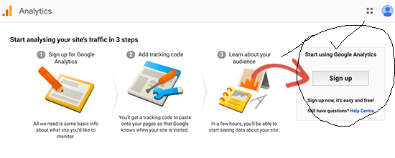
This is where one need to sign up to the Google Analytics account.
- On the next screen,

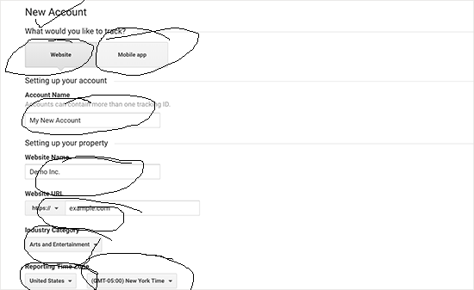

One will be given choice to choose between a website or mobile app.
After that, one need to enter account name (It will be the Google Analytics profile name for this website), Website name, website’s URL, country, and the time zone. Once one have entered this information, click on the Get Tracking ID button. One will be presented with Google Analytics terms and service which one must agree to, so click on ‘I Agree’ button.

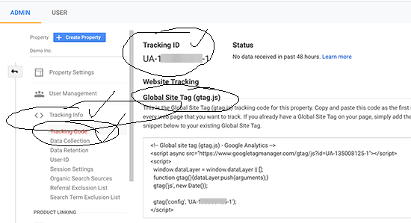

- Now, one will be presented with the Google Analytics tracking code. One can now copy this tracking code because one need to enter this code to the site.

Viewing the reports of your website by the Google Analytics:
Google analytics is able to show one the treasure of data to the website. One can see all the data from the dashboard.
One can see the reports data of the Google analytics on the left side of the Column. In this section each report is divided into different tabs and clicking on the tab one will see different options of types of report.

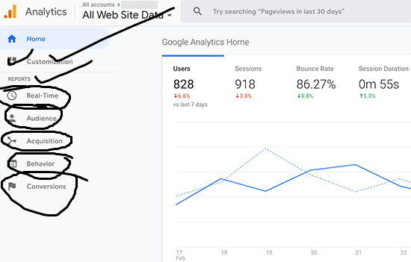
- Custom Report: Custom report is a report that one create. You pick the dimensions (city and browsers for example) and metrics (sessions, page views, bounce rate) and can decide how they should be displayed by dimensions and metrics.
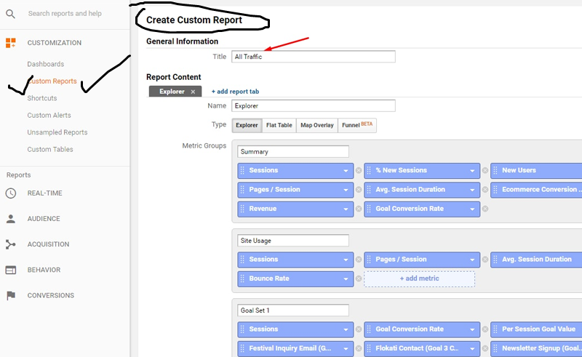

- Real Time report: This will show one the real time view of the visitors to the website. It will monitor the activity moment to moment, providing insights on how people are reacting to the marketing campaigns and infrastructure.

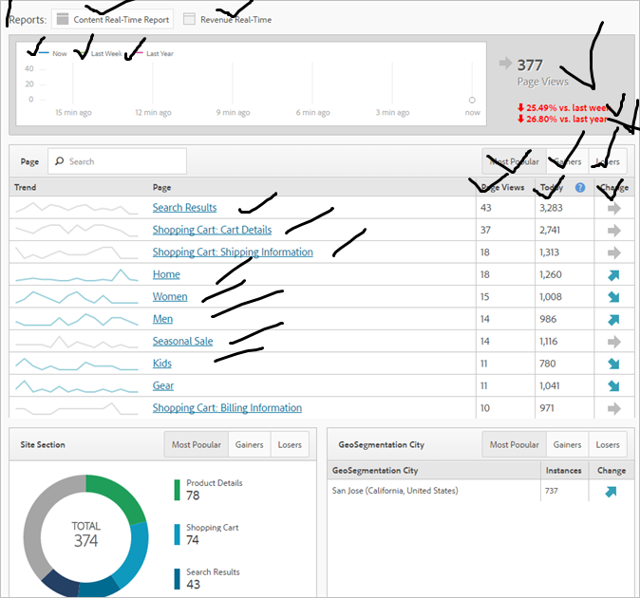

- Audience Report:

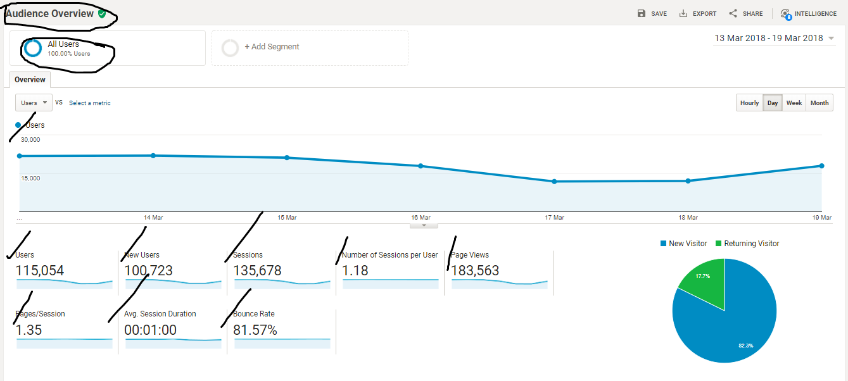
According to Google Analytics, Audience are the users that one group together based on any combination of attributes that is meaningful to one's business. Audience report will show one those reports.

- Acquisition: This tab explore reports where the users come from to one's site.

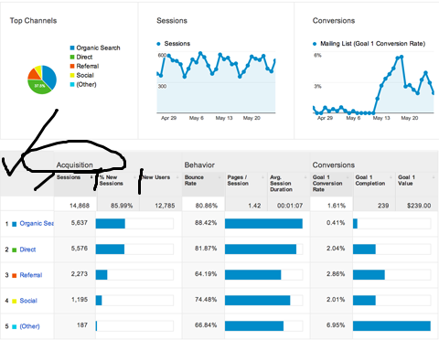

- Behavior flow report: It summarizes what the user do after they arrive on the site.

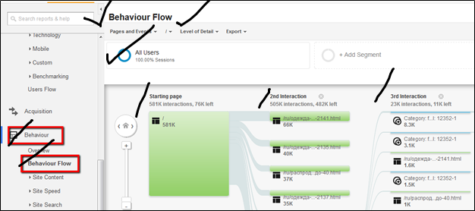

- Conversions report: It shows one the report how well one is doing on his goals.

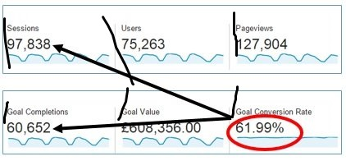

Google Analytics gives one the full overview of the sites audience, behavior and conversions. So it is very useful for Bing ad campaigns and ad groups to know which one is performing well or not.

