Orphaned & Vulnerable Children Project
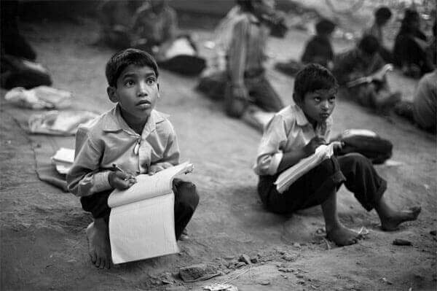
In a study made by the UNICEF, it was found that 33 million children in Bangladesh are living in poverty while about one in four children is deprived of at least four basic needs among the following: food, education, health, information, shelter, water and sanitation. Although no proper research has been conducted, it is estimated that a notable percentage of that 33 million are orphans.
We, at My Virtual People, have started a new project, simply named 'Orphaned & Vulnerable Children Project' and have chosen a group of orphan children, living under the poverty line, to educate them and finance their living.
We reached out to the destitute areas of Sylhet, Bangladesh, where we selected 6 individuals who were willing to learn English and Computer Basics. They were invited to our offshore office, where they attended an orientation programme, followed by an ice-breaking session.
Below are the profiles of the six individuals who enrolled in the debut batch of Orphaned & Vulnerable Children Project-
Name | Course
Rehana Begum | Computer Basics
Jerry Sandy | Computer Basics
Parvin Akther | Computer Basics/English
Jerald Sandy | Computer Basics
Jasmine | Computer Basics/English
Abu Sufiyan Rajib | Computer Basics/English

In the midst of busy work-life, two of our employees decided to volunteer in the project, in order to teach them. Computer Basics is being taught by Shane, our Network Manager while English is being taught by Shawn, our content writer.
The classes are held three days in a week in the afternoon. Each classes have a duration of an hour. After the end of every class, the students are given Tk.50 as an incentive. We believe, this will encourage them to attend classes regularly as this money covers their daily expenses on food and travel.
My Virtual People is strongly committed to social and environmental welfare. We went paperless almost a decade ago, and we strongly discourage use of plastics and other environmental hazardous in our office. Moreover, we arrange charity programmes every year, where our employees and many citizens (including some of our clients) from around the world donate. This is our first education project, and we believe, as it shall grow, we will be able to put our mark upon this region.

