Subject: 70% OFF ONLY ON THIS BLACK FRIDAY. DON’T MISS THE CHANCE!

Dear Customer,

Make this BLACK FRIDAY memorable. We IQCovers are offering Up to 70% less in our products only for you.

Here are the samples for you. Buy those products on https://www.ebay.co.uk/str/IQCovers?_trksid=p2047675.l2563

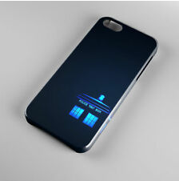 | 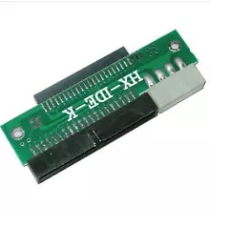 | –
Tardis Phone Booth Dr Doctor Who Phone Case Cover | LAPTOP HARD DRIVE TO BIG IDE CONVERTER READER FOR PC | 15CM Amazon Fire Stick TV HDMI Male to Female Extender Extension Wire Cable/Lead | It Pennywise 2018 Number 55 Pop! Pop Funko Toy Collectible Rare
Original Price- £6.92  ON FLASH SALE - £2. 99 | Original Price - £12.49  ON FLASH SALE - £3.75 | Original Price- £3.40  ON FLASH SALE - £2. 50 | Original Price - £28.34  ON FLASH SALE - £8.50

So, don’t miss this chance, pick your products now - https://www.ebay.co.uk/str/IQCovers?_trksid=p2047675.l2563

We wish you have an amazing BLACK FRIDAY.
Cheers!

Kind Regards
Team IQCovers.

