WHY DO COMPANIES OUTSOURCE THEIR WORK:

What Is Outsourcing?

The transformation of Outsourcing has forced to an extensive variety of Outsourcing services today. With a wide list of Outsourcing services, it is important in learning first - What is outsourcing?

Outsourcing is the business process of hiring a company or individual outside a company to perform services and create goods that commonly were performed in-house by the company's employees or the individual. From the last decade outsourcing has become a very popular or rather should say it has become a go-to way for many individuals and companies.

Types of outsourcing:

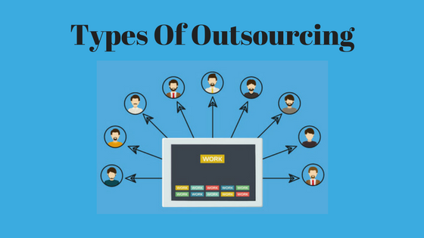

Basically, outsourcing is two types.

1. Domestic Outsourcing: Where you can outsource to an entity within the geographic boundary of your country.

2. Offshore Outsourcing: Where you can outsource a third party in a different country or overseas area.

There are so many categories of outsourcing likes, professional outsourcing, IT outsourcing, multimedia, manufacturing, designing, etc. But those all are fall in above mention broad categories.

Why Do Companies Want to Outsource Their Work?

There are so many reasons behind it. Let’s discuss the best reasons why companies outsource below……..

1. Reducing Labor and Management Costs: It is the primary reason why companies want to outsource. Outsourcing does bring down actual operational, employee and management costs. If a company hires employees for their tasks then it will cost them a huge amount of money and also increase the operational costs. So, instead of hiring employees from domestic area companies want to outsource. So, it will eventually reduce their labor costs, management cost, operational costs, etc.

2. Help Them to Focus on their Core Activities: When everything is done in-house, there is a gigantic possibility that some core aspects are not given as much consideration as needed. But if companies do outsource then their administrative or management can focus on their core business activities.

3. The luxury of Employment Handling: When things don’t go as properly planned, companies have the option to withdraw the contract or impartial fire an employee. But if they do outsource, no requirement to involve in employee disputes or be in a dilemma of whether or not to let go of someone since you have formed a bond. With outsourcing, you can let go of anyone on the fly.

4. Improved Efficiency: What is boundless about outsourcing is that you can pick a company or team that focusses on a specific skill set or knowledge. When delegating IT jobs, for example, you will be subcontracting IT-related tasks to consultants or experts, not just anyone who knows a thing or two about IT. There are plenty of companies that provide IT services performed by IT experts. With admittance to a pool of IT experts, you will be able to operate more competently. Moreover, you can tap a knowledge base for enhanced and better modernization.

5. Scope of Flexibility: There is plenty of room in outsourcing to negotiate the prices especially if the company is on a narrow budget. The company can hire low-cost labor and negotiate with the prices, something that is simply not possible in the domestic countries market.

6.Increase Business Process: If a company does outsource it will gradually improve their business process. They don’t have to pay extra hidden costs, bonus for employees. They also can give pressure to the virtual employees that their task needs to complete before the deadline.

7.Technology: Maximum times for doing a technical task a company needs to use technology and also need to buy costly hardware functionalities. For a startup company or a mid-level company, it is tough to carry those costs. So, they better go for outsourcing and they don’t even have to think about how the technology works or what type of hardware they need to buy.

8.Expert knowledge: Outsourcing companies have employees that can handle a broad variety of processes. There are also companies that have years of expertise with a once specific industry as well and know the pros and cons of that sector. Working with such a company can give them business the benefit of their expertise and experience.

