**Pen quotation for “G” program**

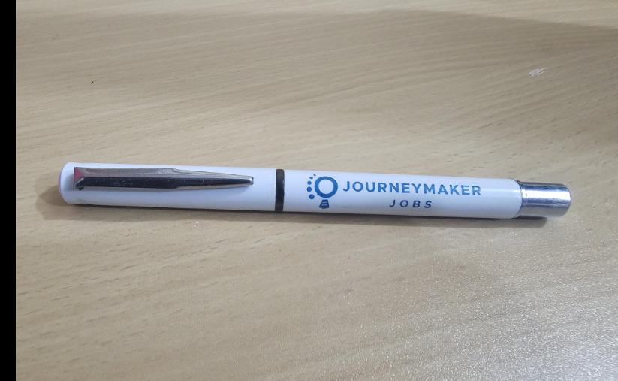

Pen price: BDT 25/pen

**Costing for print**  
  
UV Print: 15  
  
Screen print: 9

Total costing: BDT 34 to BDT 40/pen

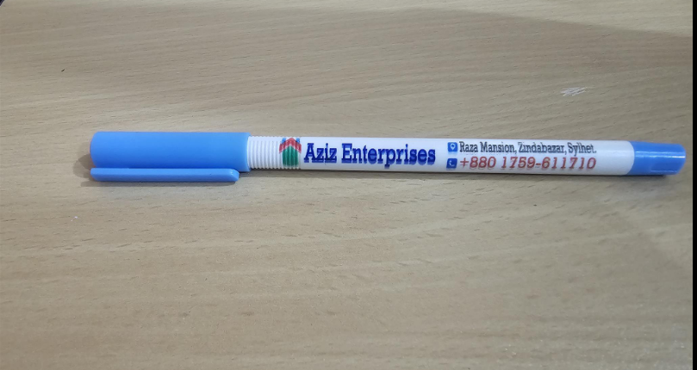

Pen price: BDT 15/pen

**Costing for print**   
  
UV Print: 15  
  
Screen print: 9

Total costing: BDT 24 to BDT 30/pen

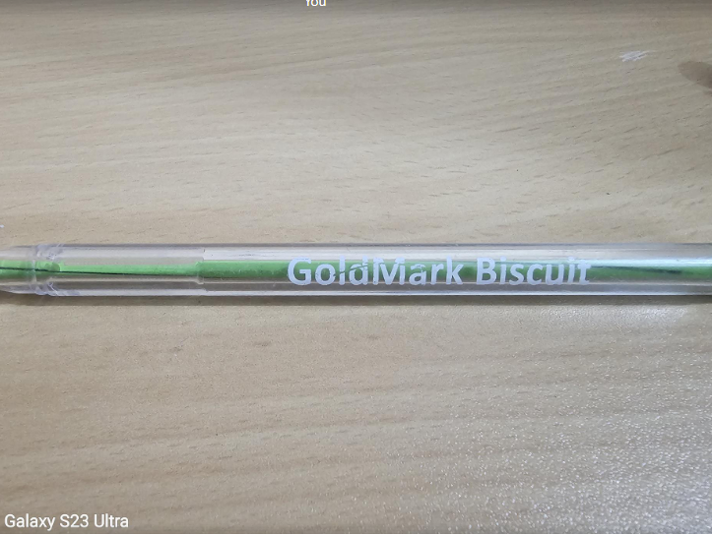

Pen price: BDT 10

**Costing for Print**  
  
UV Print: 15  
  
Screen print: 9

Total costing: BDT 25 to BDT 19/pen