Keyword research for PPC campaigns
PPC keyword research is the only way to know which keyword you should choose or use. of course there are multiple steps for this campaign however it is more simple too. In this post, we’re going to take you step by step through the process of researching and creating ad groups for your campaigns.
Start brainstorming: The very first step of the process is brainstorming. You will write all the terms that you think your audience might be searching for when they want to come across you, your products and something like your products.
Check out your competitors: Before you actually dive into the keyword research tool you have to do some homework and see what his clients are up to. We can learn a lot from what others people in the industry is up to. We can learn a lot from what other people in the industry are doing, and can even see what keywords they’re bidding most on, what they’re ranking for, and more.
My favorite tool for competitors PPC keyword research is SpyFu, but there are others
Expand your list with keyword research: Now we dive into this keyword research tools to actually expand the list of keywords you're creating. We’re still adding to the list here. Enter in terms you think your audience would be searching for even using some of the keywords already on your list and look for suggestions.
Refine your list with keyword: And now it’s time to go ahead and make cuts. It’s important to focus on expanding your list separately before you start cutting so that you can make rational decisions.
Ideally, you’ll be able to find high search volume, low competition, low-cost keywords as often as possible. That being said, don’t just look for low-cost. Some of your most high-value keywords could cost more, but be well worth it because they send more conversions or send you customers that buy more expensive products or services. Take all of this into consideration when you start to cut keywords from your list.
Group keywords into ad groups: Once you’ve trimmed away the excess, you’ll have your solid list of keywords that you want to target. All that’s left is to sort them into different ad groups.

The above five steps are to follow for the keyword research however there are some other things I would recommend:
Consider keyword match type: The effectiveness of the keywords you choose could be directly affected by the keyword match type you select. Broad match, for example, lets search engine leave things open to their own interpretation. Exact match, however, may limit you from great potential placements. You can read more about match types here and see what’s right for you.
Don't forget negative keywords: The negative keywords you choose are almost as important as everything else we’ve done on this list. They can keep you from appearing in irrelevant searches and (even worse) from getting irrelevant clicks.
Know that all strategies are worth copying: Competitors research can be a recourses of knowledge but if you see that your competitors is spending a lot on a certain keywords that likely wouldn't benefit you but cost you a lot think twice before adding it to your list.
How to use keyword tools for keyword research (PPC):
There are many renowned tools for keyword research. Some are paid and some are free. Now I am showing examples of two tools for keyword research:
Ubersuggest:
Keyword research with Ubersuggest:
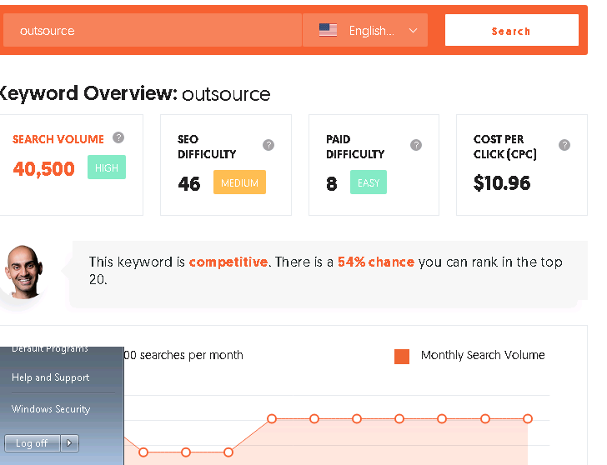
In this picture it showing the search volume, SEO difficulty level and CPC with graphics of the Keyword ''Outsource''.
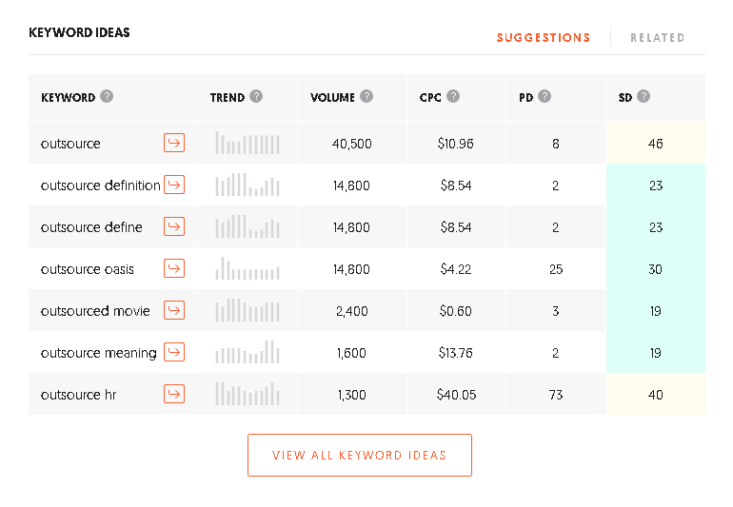
In this picture it showing the search volume, SEO difficulty level and CPC with analytics of the Keyword ''Outsource''.
Keyword research with Soovle:
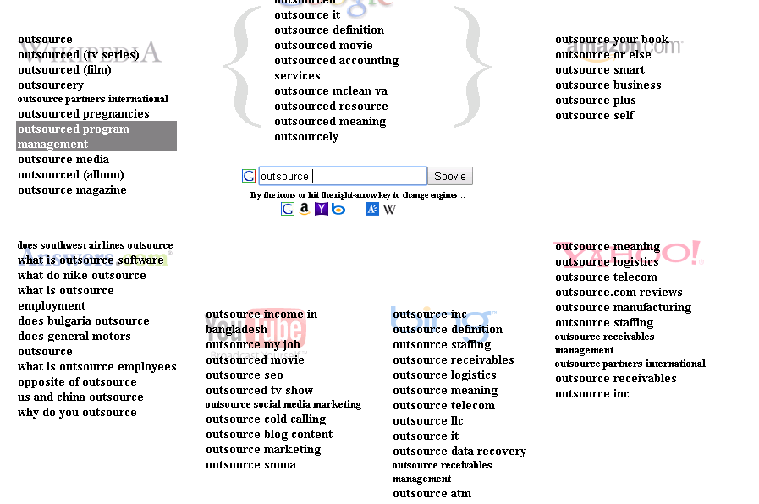
In this picture it showing the keyword list of the keyword ''outsource'' in the different search engines all together.

Conclusion: PPC keyword research is the most important part of strategy for search ads so to get it right. Even though the research involves multiple steps. You can create multiple ad groups in one sitting and benefit from the data long-term.

