The True Cost of Hiring an Employee in USA

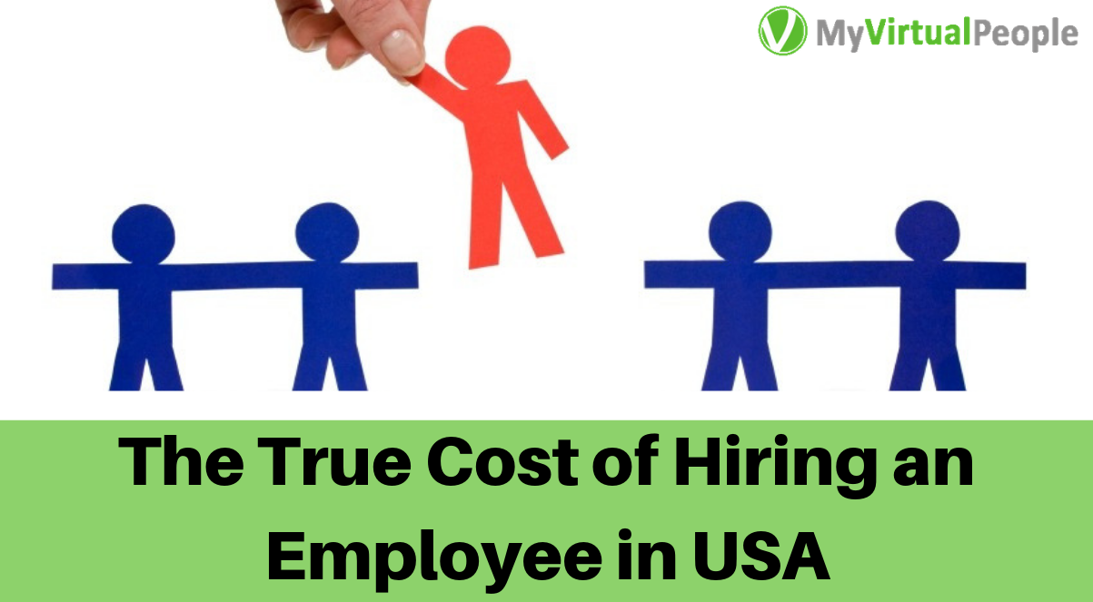

If you’ve just set up your mind to hire a new employee, you are going to face some hard time because hiring a new employee physically is extremely complex and it takes a lot of time money skills patience to get the right person to fill the position in your company.
There are a number of factors consider while calculating the cost to hire an employee for a specific company. However, the hiring process is similar for most organizations. Let's see a breakdown of some of the common hiring cost factors so that you can get a better idea about how much it may cost to hire a new employee in the USA

1. External/Internal hiring team: Most of the small business don't require a dedicated hr team or hr professional. So, in that case, they use external hiring agencies to hire a new employee. The fees for such hiring agencies are anywhere from 15 to 25% of the employee’s annual salary and for more senior positions they demand even more. And if you have an internal hiring professional, you are already paying for hire. For an internal HR manager, you are already paying in general estimates are anywhere from $91,000 to $120,000 per year, with healthcare on the lower end and company management on the higher end of the scale. Of course, your hiring manager/team might have many other tasks when you are not hiring an employee. But in the time of your hiring, they focus on hiring the new person. This means you are spending money on hiring a new employee.

2. Career events: Career events or college career fairs are most popular in the United States in recent days, where 75% of all employers visit these types of events. Employees get to go out there and meet prospective new employees in person. The cost of participating in a single event like this ranges from $125-225. And it does not include other costs like accommodation cost, travel, marketing materials, etc costs.

3. Online job posting: You can use online job posing platforms to hire a new employee. But, placing a job ad on an online platform is not free, and it adds up to the total cost of hiring an employee. LinkedIn is one of the coolest online platforms to get a dedicated employee. Previously LinkedIn used to charge $495 for 30 days for one position. Last year, it was changed to a pay-per-click model. Currently, it will cost you $1.20 to $1.50 for a single click on your job ad, depending on job title, location, and competition. You can also use online job platforms like Monster, Dice, ZipRecruiter and these will cost you on average $300 per month to advertise a single job position.

4. Background checks: When you find someone you may hire it's safe to check their background before making an offer. You can check his/her education, previous employers, to criminal databases, etc. One of these checks can cost you $5 to $80 for per single applicant, depending on how detailed information you want about them.

5. On boarding and training: When you hire someone new it's very normal that they won’t be fully productive their first day of work. It will take a few months or even more to get comfortable in their position. Research shows that it takes 8 to 26 weeks for an employee to achieve full productivity. But in the training period, you are giving him full payment but he is giving your company less profit. This means you are losing money in this period. And on the other hand, you are also spending time with him to train him up for work. So you are spending your valuable time on him and it's also costing you a lot. another statistics shows that an average company loses anywhere between 1% and 2.5% of their total revenue on the time it takes to bring a new employee.

6. Salary + extras: When you hire a new employee and offer them a certain amount of money, they know exactly how much they’re getting. But in background you have to pay some extra costs like taxs for your employee. For example in United States if basic salary of your employee is $50,000 per year, your costs are anywhere from 1.25 to 1.4 times higher than the base. it means that for the employee to receive $50,000, you have to pay from $62,500 to $70,000 per year. And your employees won’t expect their salary to stay the same either. You have to pay them more as the time goes. A statistics shows that the average increase in salary per year is 2.7%.

The total cost of hiring an employee in the USA: It's really hard to find out exactly how much it cost to hire new employee in USA as it depends on many factors. However, below some general guidelines to make an educated guess.
- According to National Association of Colleges and Employers : hiring an employee in a company with 0-500 people costs an average of $7,645.
- According to another study by Society for Human Resource Management : the average cost to hire an employee is $4,129, with around 42 days to fill a position.
- And according to Glassdoor research, most of the companies in the USA spends about $4,000 to hire a new employee, taking up to 52 days to fill a position.

Worried about all these costs of hiring a new employee? Outsourcing can be an alternative way to escape you from most of these costs. Read these 5 WAYS OUTSOURCING WORK REDUCES YOUR BUSINESS COSTS.

