Review on DrumUp, online article searching tool

I checked DrumpUp. This tool is useful in finding articles by category/hashtags.
See the screenshot below
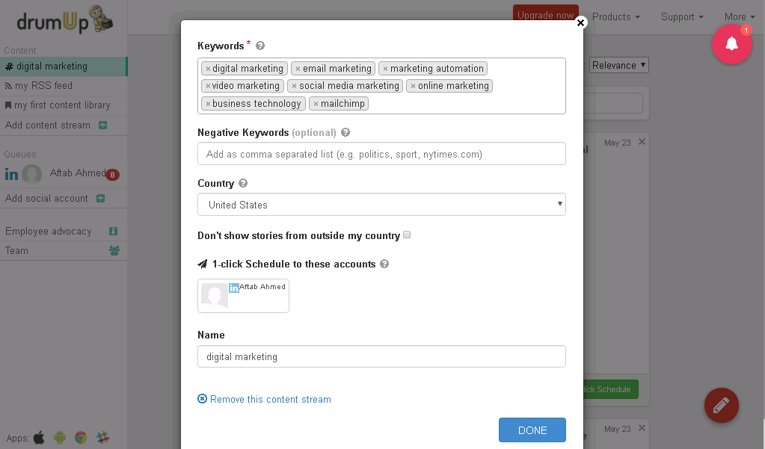

Benefits:
# Here we will give them categories names and they will find articles according to our preferences.
# Allow setting negative keywords.
# Allow country wise search.

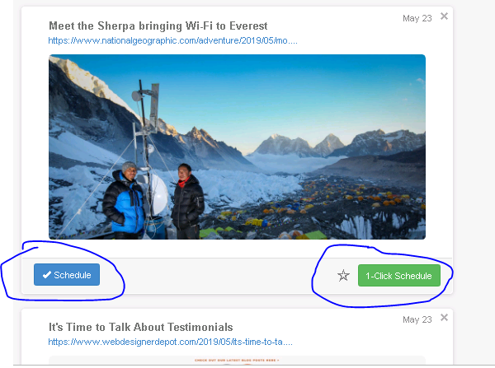

Here they find out some articles according to my category setting.
Benefits:
# We can schedule the collected posts from here to share them on social media accounts. They are able to suggest hashtags and mentions while scheduling.
# Another benefit of DrumUp is that we can create our own content library here and can schedule the post for social media accounts.
Issues with DrumUp:
But I found their article sourcing is not too good. I searched using a single category like "Bitcoin" and they retrieve most irrelevant articles. Tried using some other category like "Online Marketing" and they retrieve many irrelevant articles. I think they gather articles by #Hashtags and most people used to add many irrelevant hashtags with their articles/blog posts.
Alternative tool of DrumUp:
Here is another very similar online tools named "Pocket (https://getpocket.com)". This one is also for collecting articles. I used to find articles using this one while working with Steve (my last client)
Benefits:
# Gives most relevant articles.
# Can see how many people saved the article. So we can know on which types of articles people are more interested in.
# Can save the articles by categories/tags.
# They have categories like "Must Read", "Trending", "Tech", "Finance" etc where they show the most viewed and read articles.
# They fetch articles by search title, not by hashtags.
# Most of their fetched articles from top article websites like Forbes, Entrepreneurs, etc.

As I'm working to rewrite various articles for MVP I will use these both online apps. But still I would say Google search is best in finding articles.

