Mistakes in Managing Multiple Projects (Top 5)

Part 4: Software & Technology

In a modern complex, technologically progressive business context, project managers have a diverse advantage. In the last few years, there has been a compact increase in technologies that were manufactured to improve and reorganize project development with better synchronicity, making a project manager’s job more manageable, more spontaneous and more easily flexible to the ever-changing technological scenery.

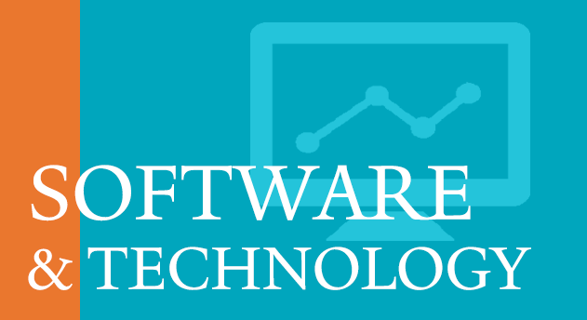

Project managers nowadays having so many technologies still make mistakes while managing multiple projects. They need to choose the right software for the right work. Let’s discuss how project managers in current days make mistakes while managing a project.

Mistake #4: Copying Information Back and Out

Project managers often find themselves running about from meeting to meeting, calling individuals and sending tons of emails to request status informs or sprout off cues about upcoming deadlines.
By doing this project managers duties can become devastating and even robotic. It may feel them their role is just gathering information and updating their work plans since most of them working hours are expended congregation data and updating project schedules.
But project managers must have to remember that, they still have to lead their team. Not only lead but also, they have to motivate them. Project managers have to know the work progress of the project from the team members. The main problem occurs here, how many project managers nowadays has the time for that?

Winning Strategy #4: Using Right Technologies In Right Place.

Instead of harassed to get all that busywork done, the well tactic would be to use the right software and technology to help with the inundation of information project managers need to trade with.

Combine Your Information

When a project manager starts their projects, they need to combine all their information related to the project. They will need a dependable tool that will help them integrated their information.

Those tools will make a project manager’s life easier. They will get the full view of their project.

Project Scheduling Software:

Having a proper project scheduling you know exactly what should be delivered in what order. It will help you find and assign the right employees. Then, it will also tell you exactly when all of that should happen. So, for making a proper project schedule project manager need to find the best project scheduling software. Project Scheduling software will consolidate project managers reporting for each project and accomplish one standard.

Choose Flexible Technology:

Choose a flexible technology that will let a project manager easily integrated their plans. There are so many flexible web-based applications on the internet that will allow team members to update tasks. This will save lots of time for a project manager. Project managers don’t have to inform individual employees about the updates of the tasks, tools will notify them.

For the better project management project managers can use project tracking, budget tracking, information-gathering tools, workflow automation tools, time tracking tools, data and storage backup tolls, etc.
Such tools will help project managers to overcome the mistakes of managing multiple projects at a time.

